**CHEMICAL INFORMATION MANAGEMENT SYSTEM C.I.M.S**

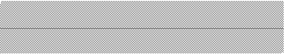

User Manual (Officer)

**DEPARTMENT OF OCCUPATIONAL SAFETY AND HEALTH (DOSH)**

**MARCH 2011**

***@ INFOTREE SDN BHD***

**User Manual for Officer Module**

Chemical Information Management System

Department of Occupational Safety and Health Malaysia

**CONTENTS**

**USER MANUAL FOR OFFICER MODULE ....................................................................................... 2**

CHEMICAL INFORMATION MANAGEMENT SYSTEM ................................................................................. 2

**MAIN SCREEN...................................................................................................................................... 3**

**LOGIN.................................................................................................................................................... 3**

**HOME .................................................................................................................................................... 4**

NEW SUBMISSION: WAITING FOR CHECKING ................................................................................................... 5

NEW SUBMISSION: ACKNOWLEDGE ....................................................................................................... 7

NEW SUBMISSION: REJECTED ................................................................................................................ 9

RENEWAL SUBMISSION: WAITING FOR CHECKING ................................................................................ 11

RENEWAL SUBMISSION: ACKNOWLEDGE ............................................................................................. 13

RENEWAL SUBMISSION: REJECTED ...................................................................................................... 15

NEW CHEMICAL ................................................................................................................................. 17

**INVENTORY ....................................................................................................................................... 18**

SUB MENU ......................................................................................................................................... 19

ACTIVITY BUTTON.............................................................................................................................. 19

CHEMICALS LIST ................................................................................................................................ 20

SYNONYM LIST................................................................................................................................... 22

CLASSIFIED CHEMICALS ............................................................................................................................ 23

UNCLASSIFIED CHEMICALS ........................................................................................................................ 24

**SUBMISSION .......................................................................................................................................... 25**

SUB MENU ............................................................................................................................................ 25

ACTIVITY BUTTON ................................................................................................................................... 25

ALL SUBMISSION: LIST ............................................................................................................................. 26

NEW SUBMISSION: ALL LIST ...................................................................................................................... 28

RENEWAL SUBMISSION: ALL LIST ................................................................................................................ 31

**REPORT .................................................................................................................................................. 33**

**PROFILE.................................................................................................................................................. 34**

**Main screen**

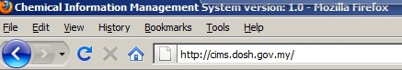

Web address: <http://cims.dosh.gov.my>

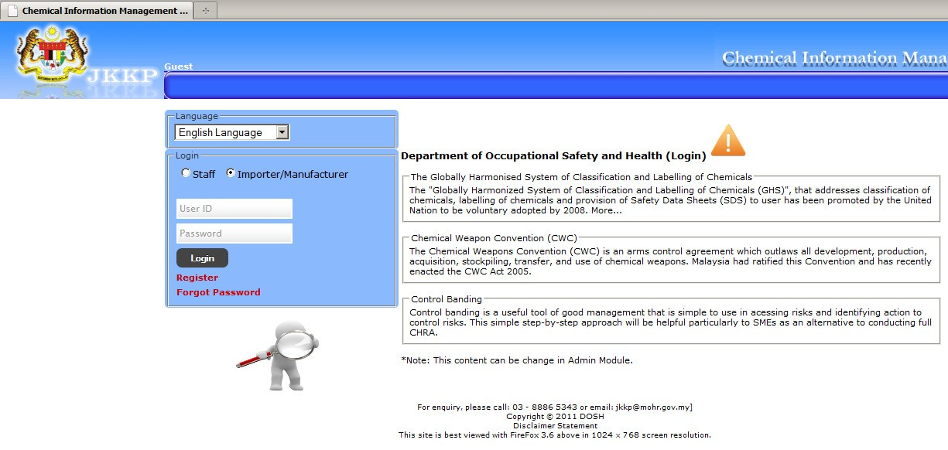

Home screen

**Login**

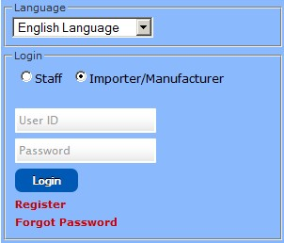

**Home**

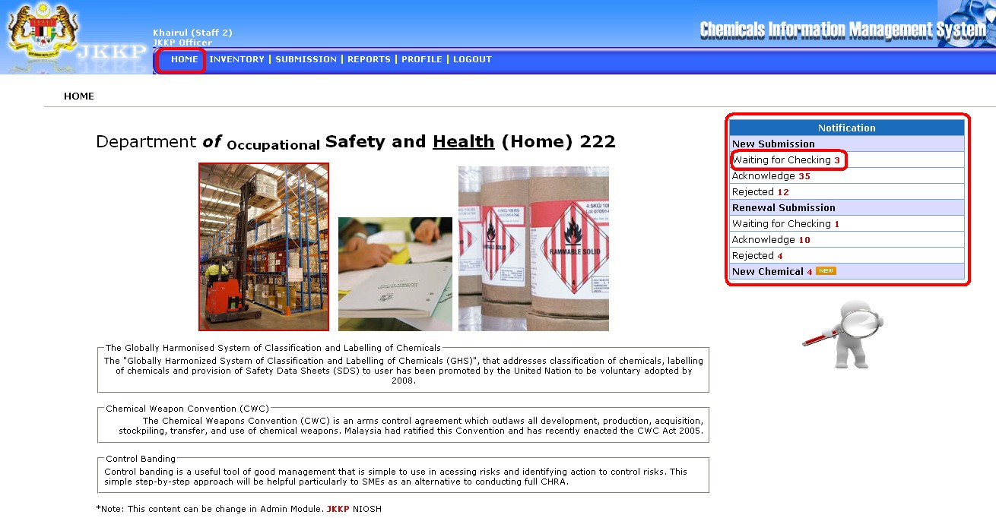

Home screen for officer

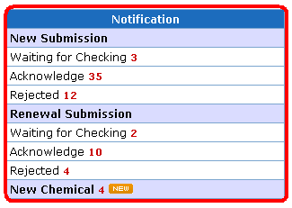

Notification shortcut for submission and new status

Search chemical information



***New Submission: Waiting for Checking***

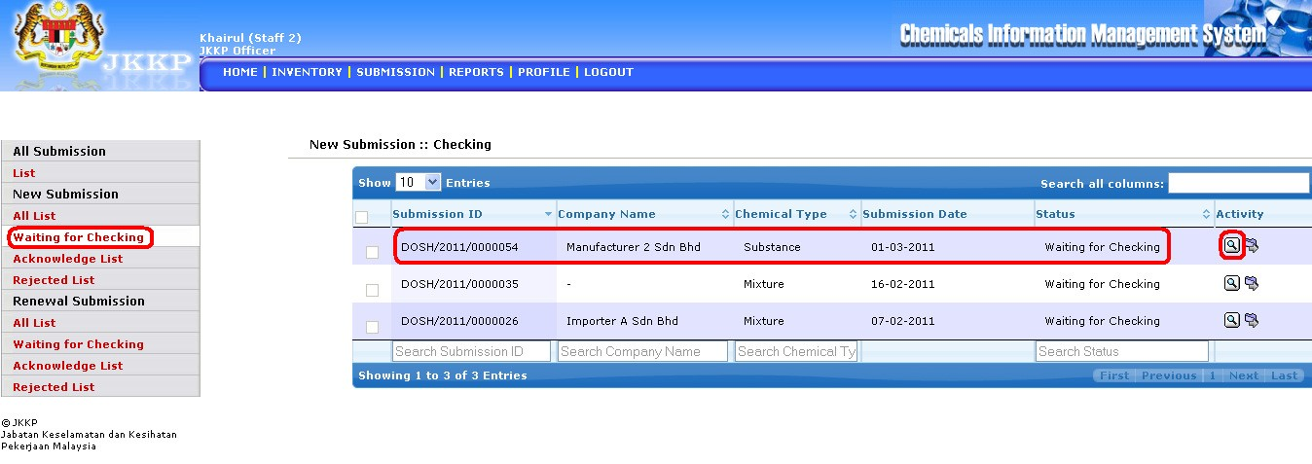

• List of waiting for checking new submission

• Click View button

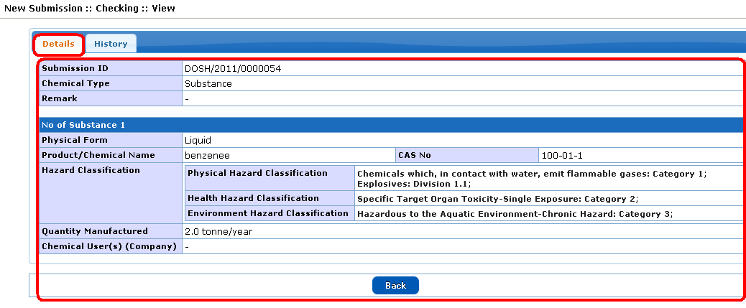

• Details for waiting list

• History for waiting list

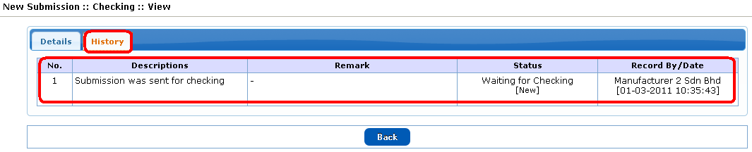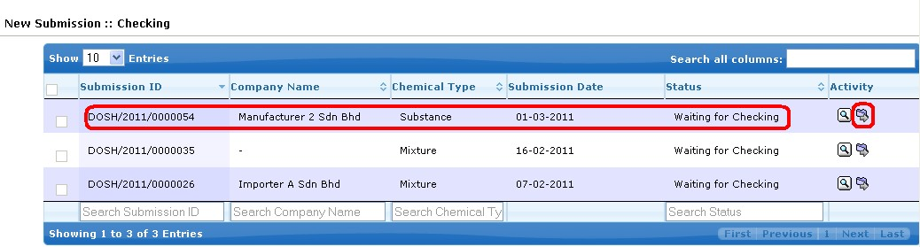

• Click Checking button

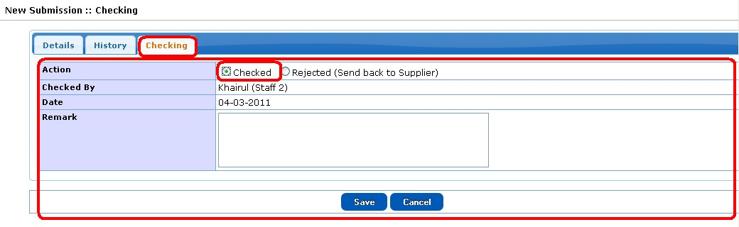

• Click Checked radio button after checked the checking list

• Click Rejected radio button to reject the list

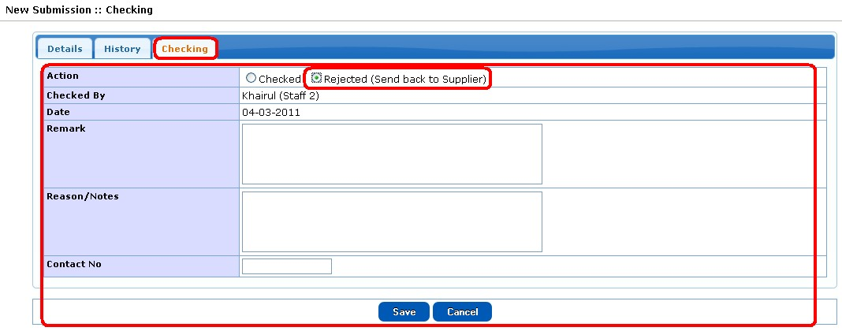

***New Submission: Acknowledge***

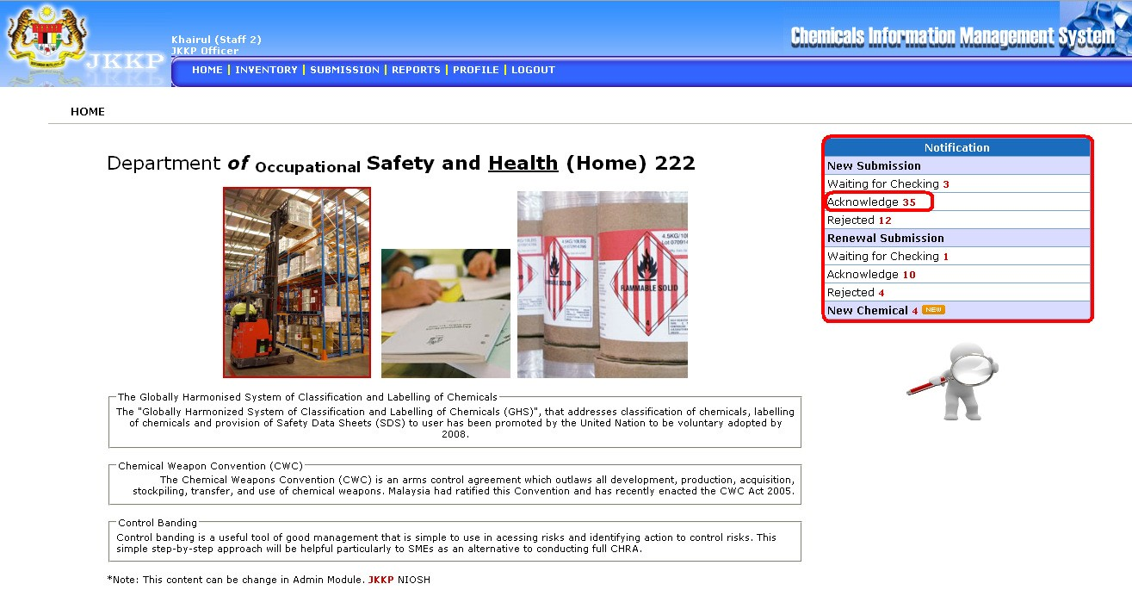

• List of acknowledge new submission

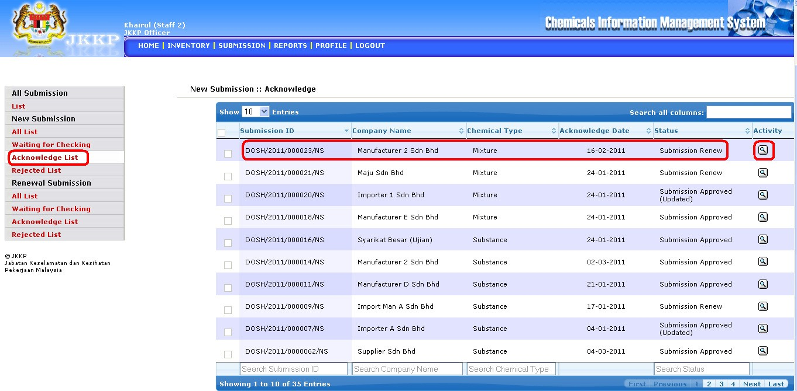

• Click view button

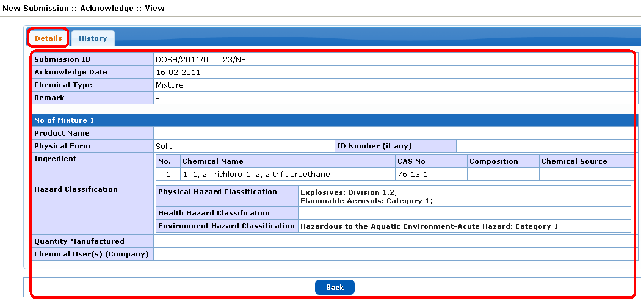

• Details of acknowledge list

• History of acknowledge list

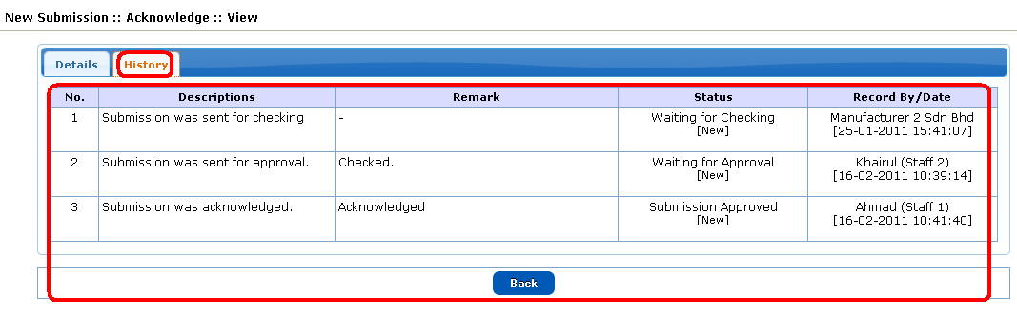

***New Submission: Rejected***

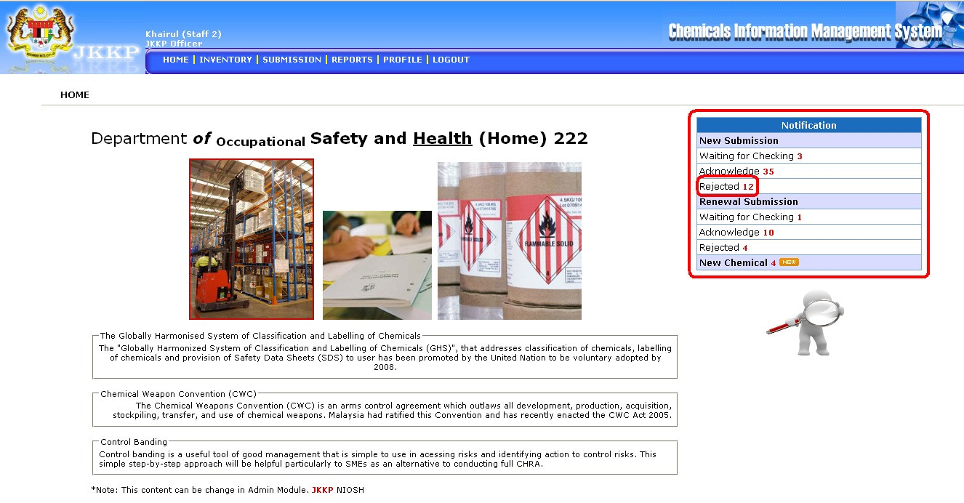

• List of rejected new submission

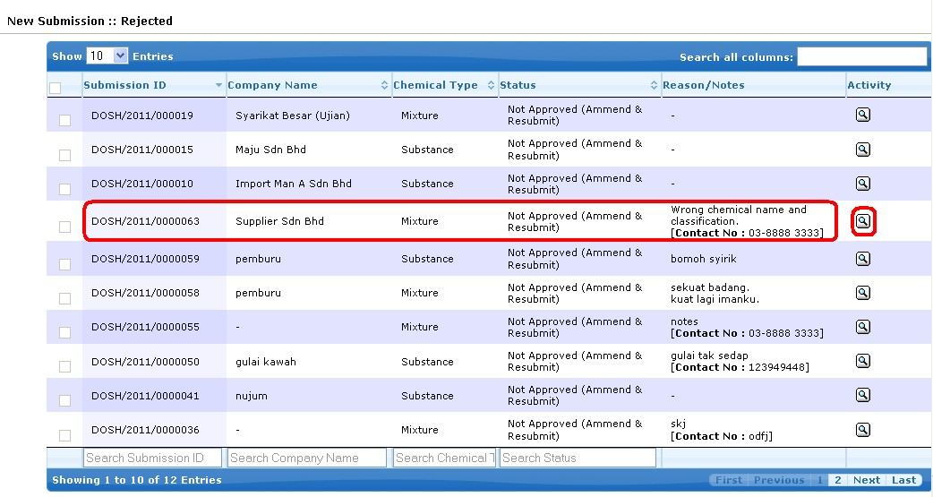

• Click view button

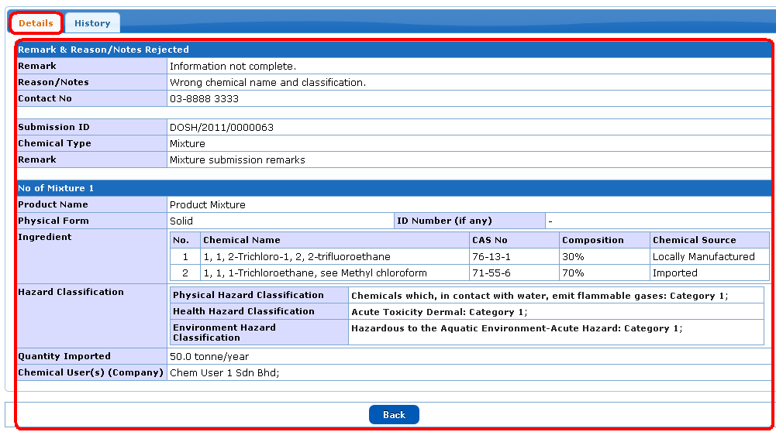

• Details for rejected list

• History for rejected list

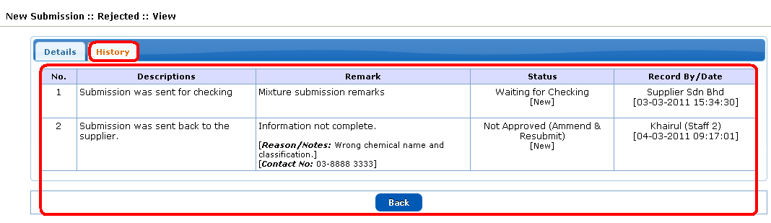

***Renewal Submission: Waiting for Checking***

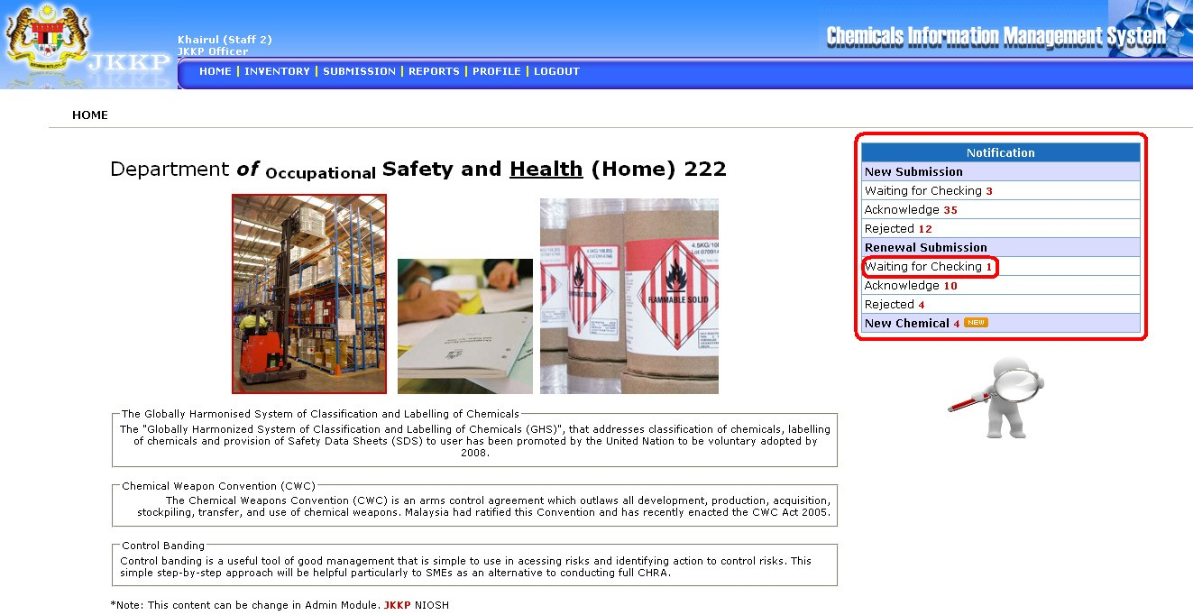

• List of waiting for checking renewal submission

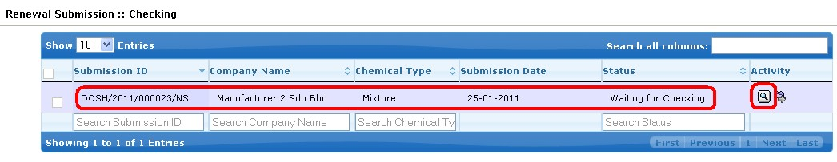

• Click View button

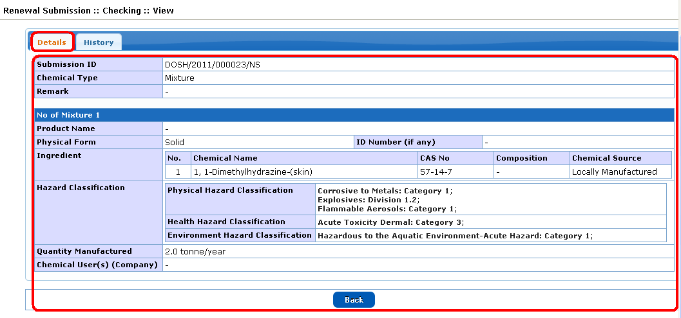

• Details for waiting list

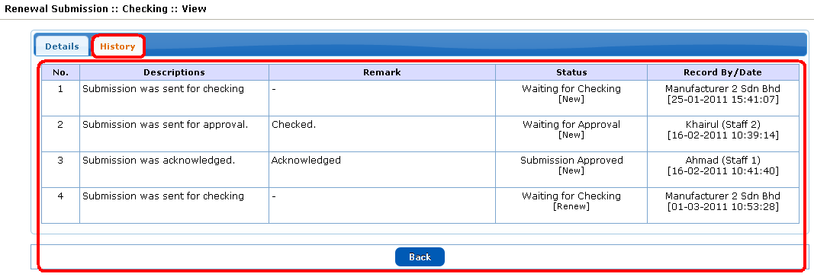

• History for waiting list

***Renewal Submission: Acknowledge***

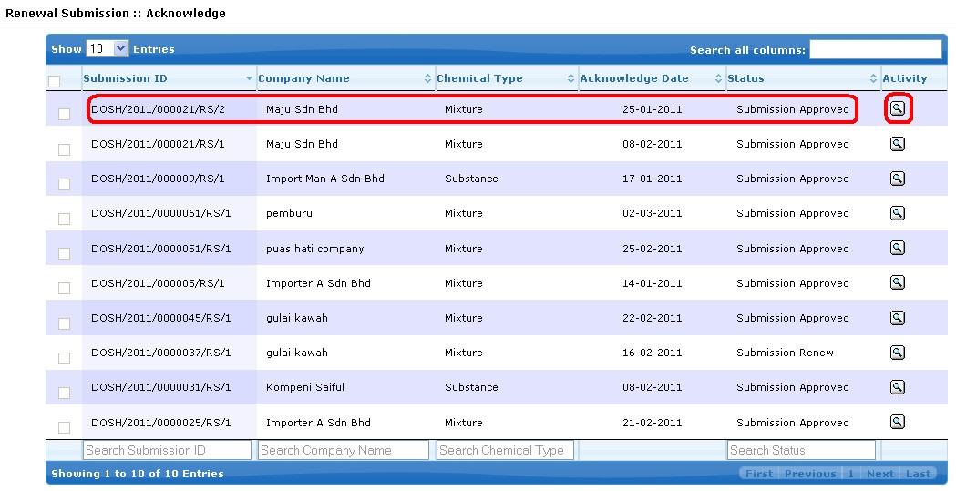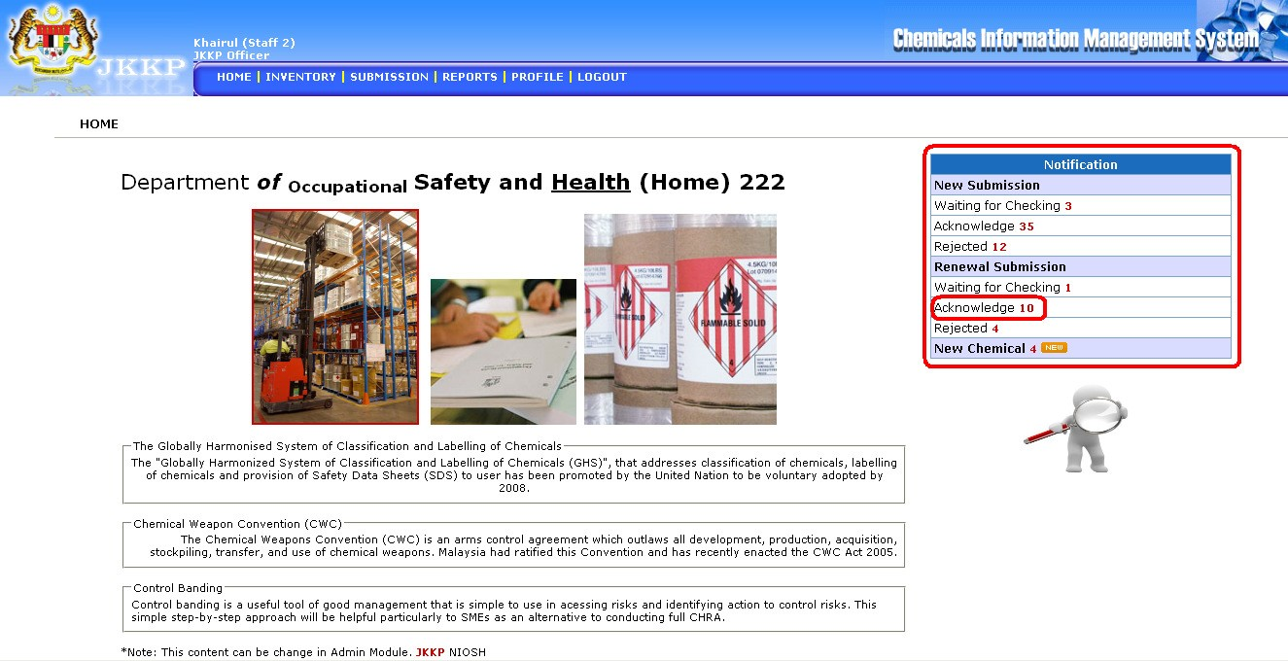

• List of acknowledge renewal submission

• Click view button



• Details for acknowledge list

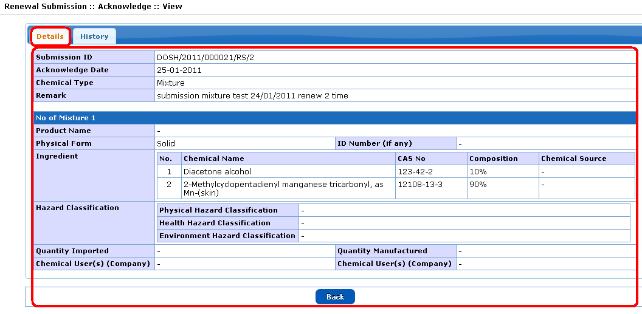

• History for acknowledge list

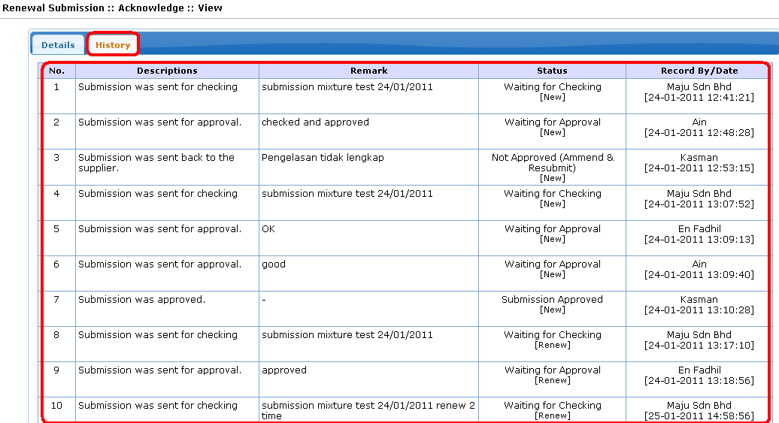

***Renewal Submission: Rejected***

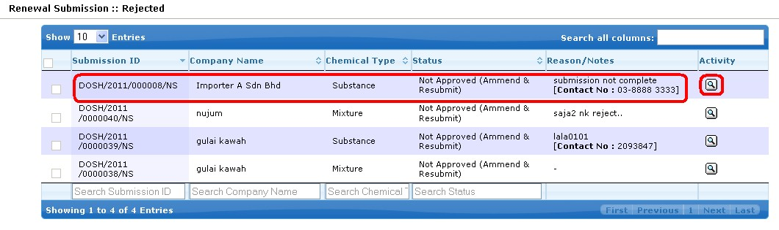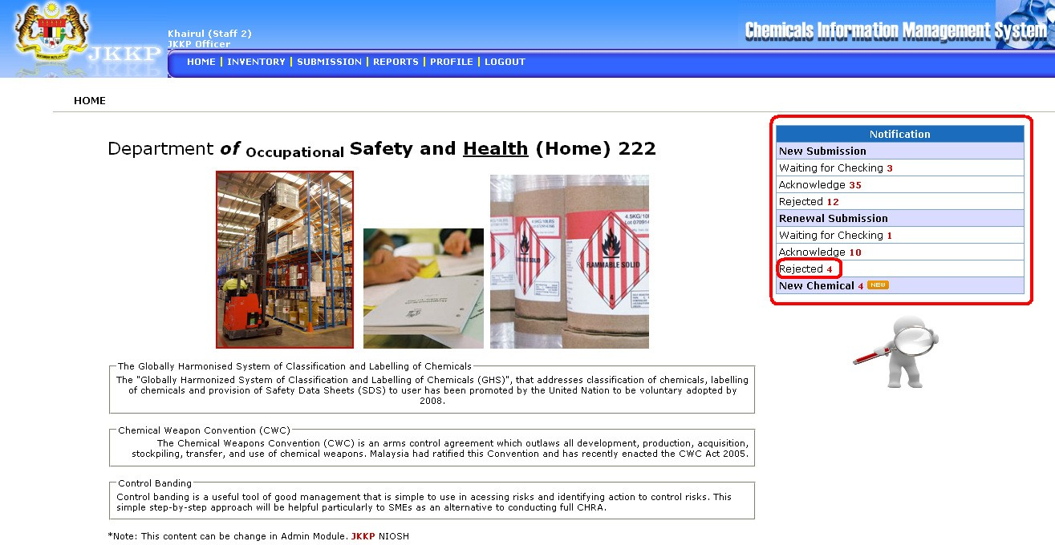

• List of Rejected renewal submission

• Click View button



• Details for rejected list

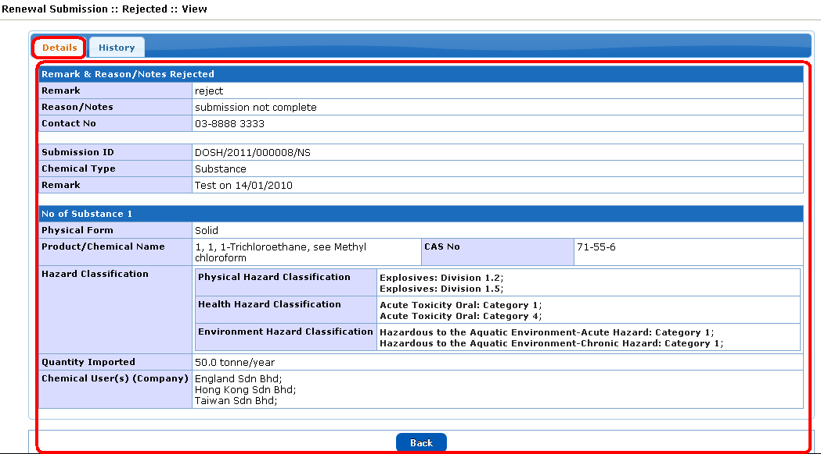

• History for rejected list

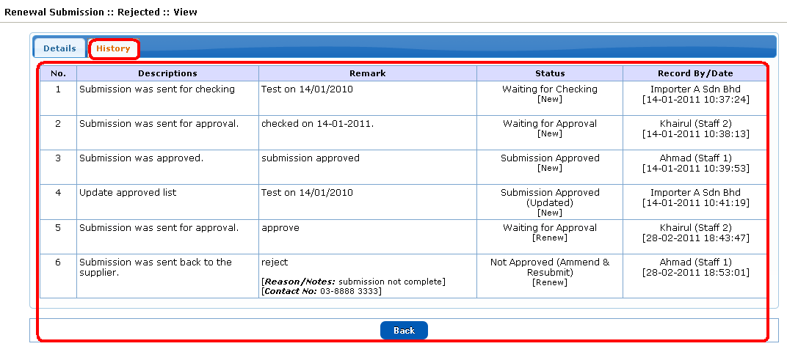

***New Chemical***

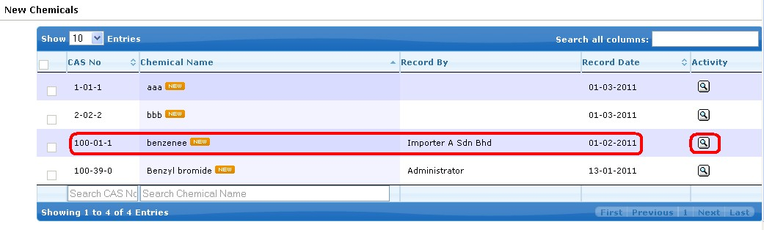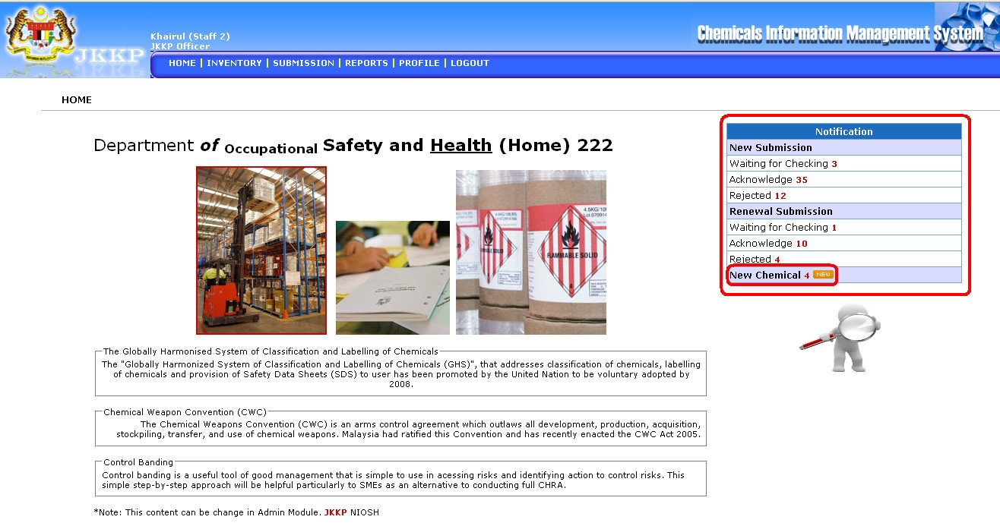

• List of new chemical

• Click View button

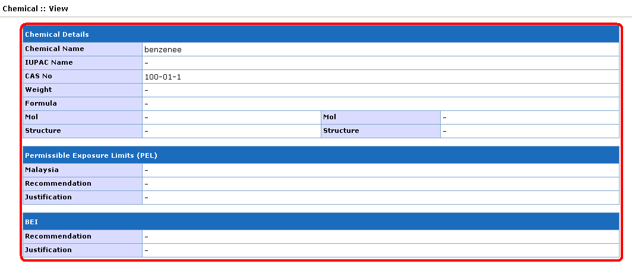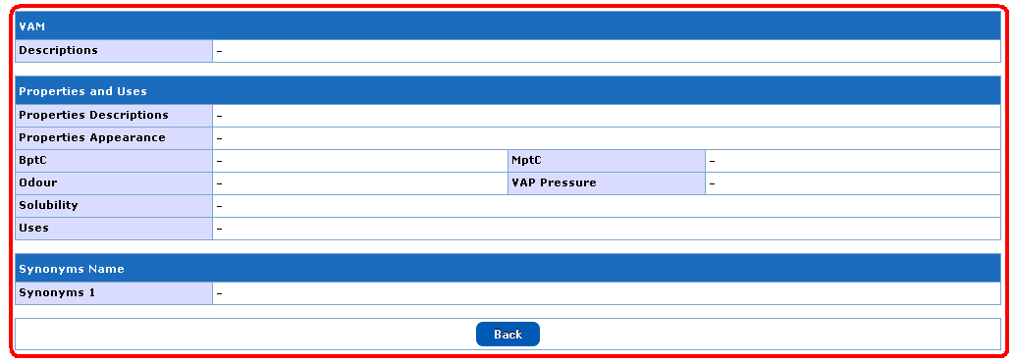

• View of new chemical

**Inventory**

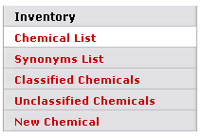

Inventory sub menu

***Sub Menu***

|  |  |  |
| --- | --- | --- |
| **No** | **Menu button** | **Descriptions** |
| **Inventory** | | |
| 1 | Chemical List | List all chemical list |
| 2 | Synonym List | List all synonym list |
| 3 | Classified Chemicals | List all classified chemicals |
| 4 | Unclassified Chemicals | List all unclassified chemicals |
| 5 | New Chemical | List all new chemical |

***Activity Button***



|  |  |  |
| --- | --- | --- |
| **No** | **Button** | **Descriptions** |
| 1 |  | View record details |
| 2 |  | Edit record |
| 3 |  | Download records/certificate |
| 4 |  | Renew submission |

***Chemicals List***

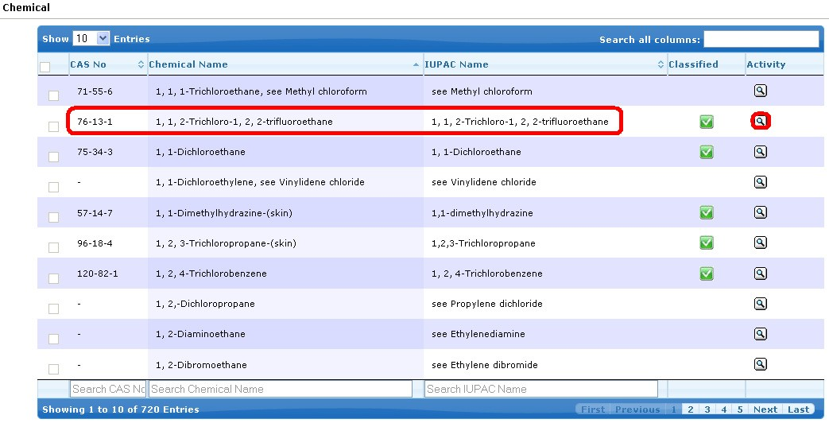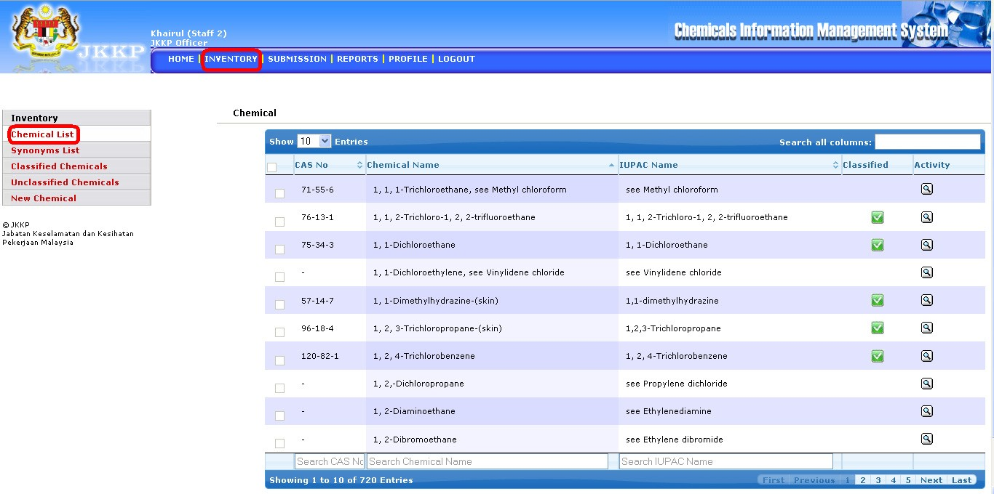

• List of chemical

• Click View button

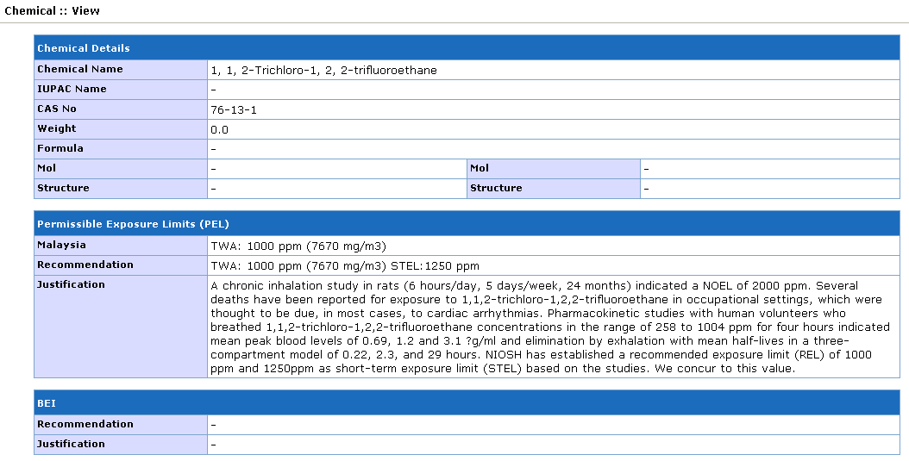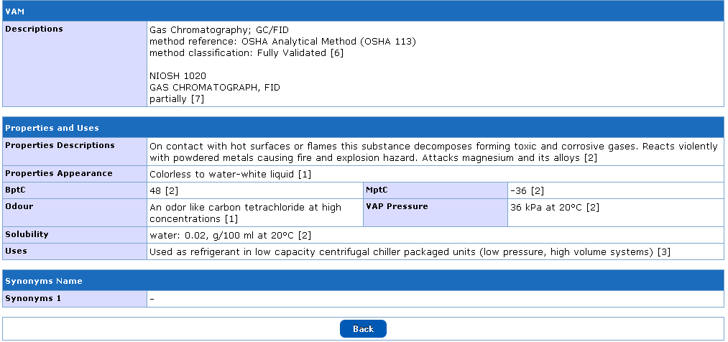

• View of chemicals list

***Synonym List***

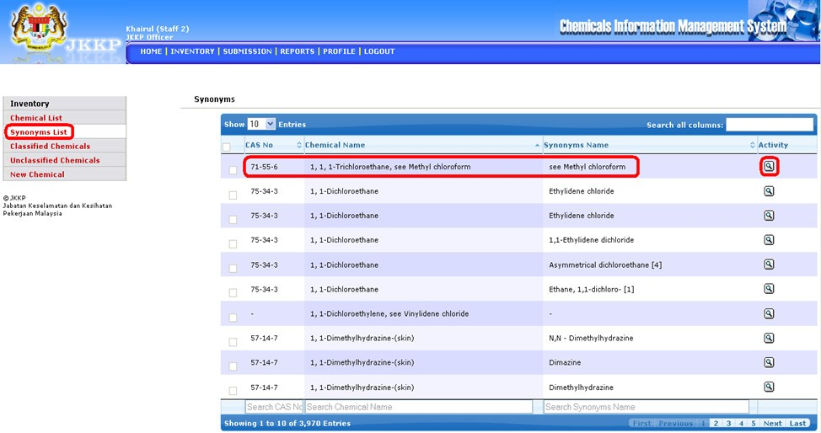

• List of synonyms chemical name

• Click View button

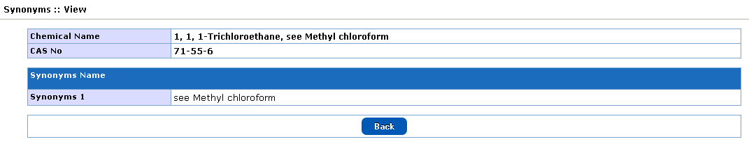

• View of synonym name

***Classified Chemicals***

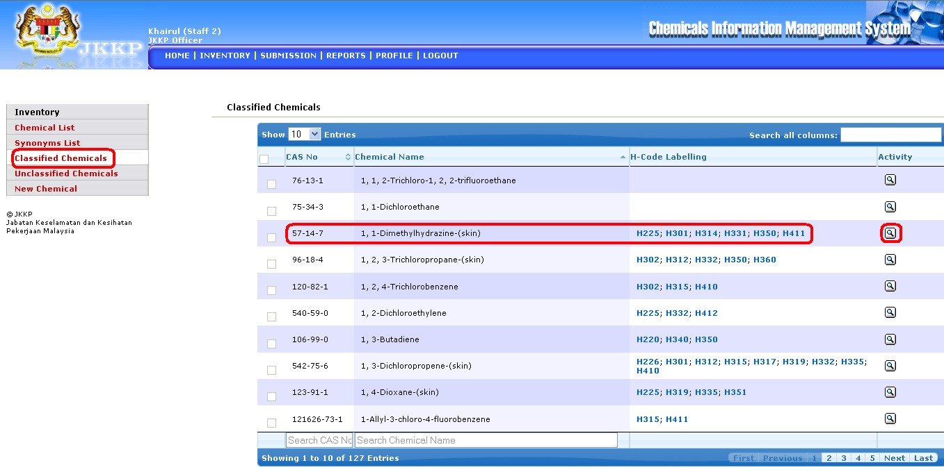

• List of classified chemicals

• Click View button

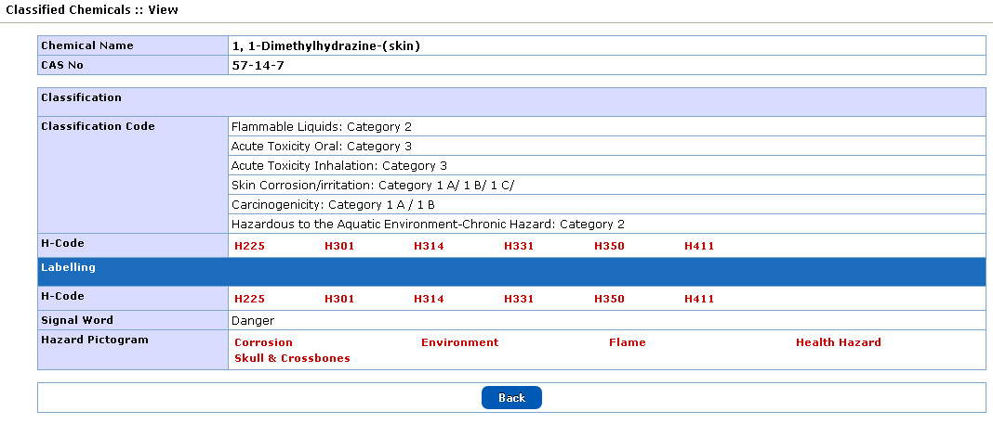

• View of classified chemicals

***Unclassified Chemicals***

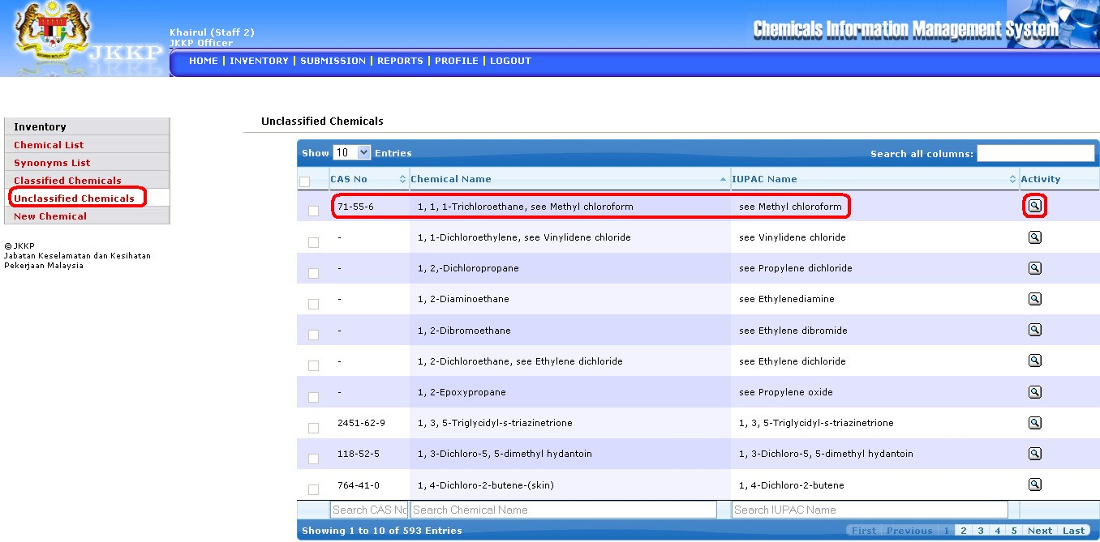

• List of unclassified chemicals

• Click View button

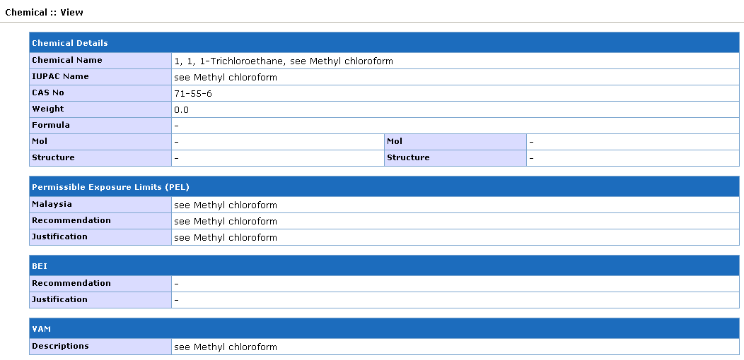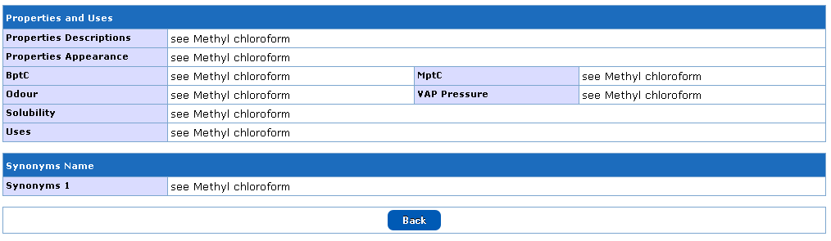

• View of unclassified chemicals

**Submission**

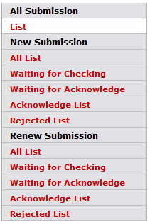

***Sub menu***

|  |  |  |
| --- | --- | --- |
| **No** | **Menu button** | **Descriptions** |
| **All Submission** | | |
| 1 | List | List all submission with status |
| **New Submission** | | |
| 2 | All List | List all new submission only with status |
| 3 | Waiting for Checking | List new submission which is waiting for checking |
| 4 | Waiting for Acknowledge | List new submission which is waiting for acknowledge |
| 5 | Acknowledge List | List all acknowledge submission |
| 6 | Rejected List | List all rejected submission |
| **Renewal Submission** | | |
| 7 | All List | List all renewal submission only with status |
| 8 | Waiting for Checking | List renewal submission which is waiting for checking |
| 9 | Waiting for Acknowledge | List renewal submission which is waiting for acknowledge |
| 10 | Acknowledge List | List all acknowledge submission |
| 11 | Rejected List | List all rejected submission |

***Activity Button***



|  |  |  |
| --- | --- | --- |
| **No** | **Button** | **Descriptions** |
| 1 |  | View record details |
| 2 |  | Check list |
| 3 |  | Download records/certificate |
| 4 |  | Renew submission |

***All Submission: List***

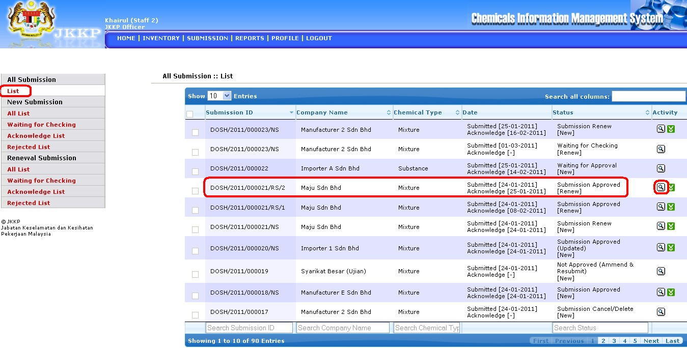

• List of all submission list

• Click View button

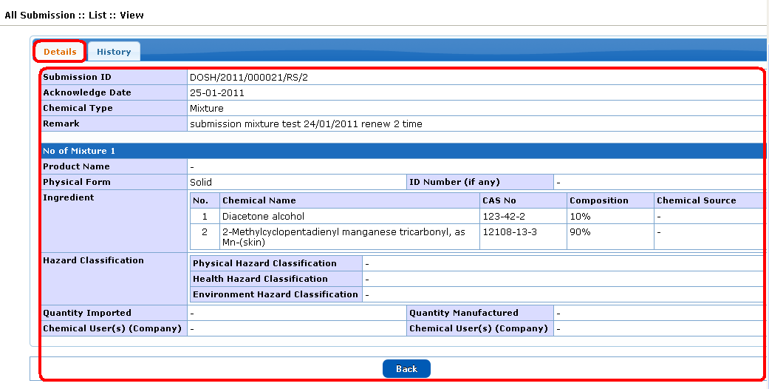

• Details of list all submission

• History of list all submisssion

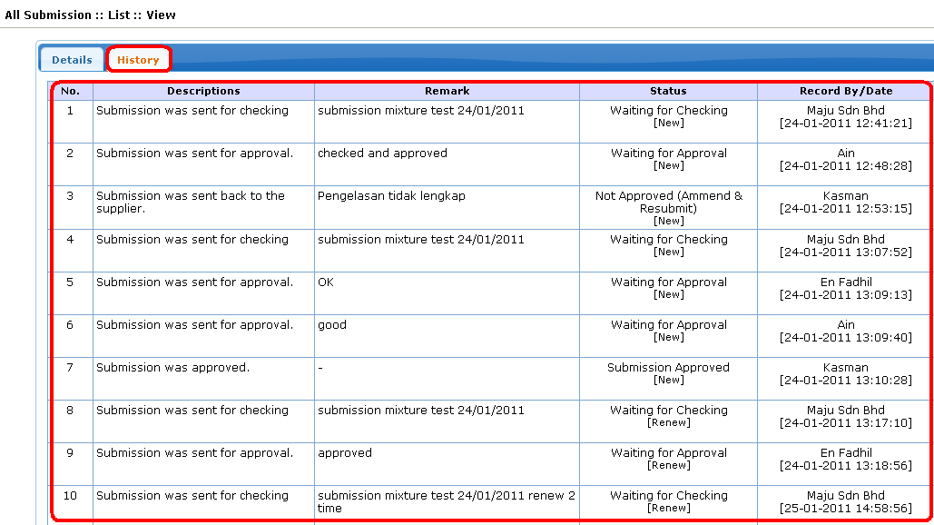

• Click download button

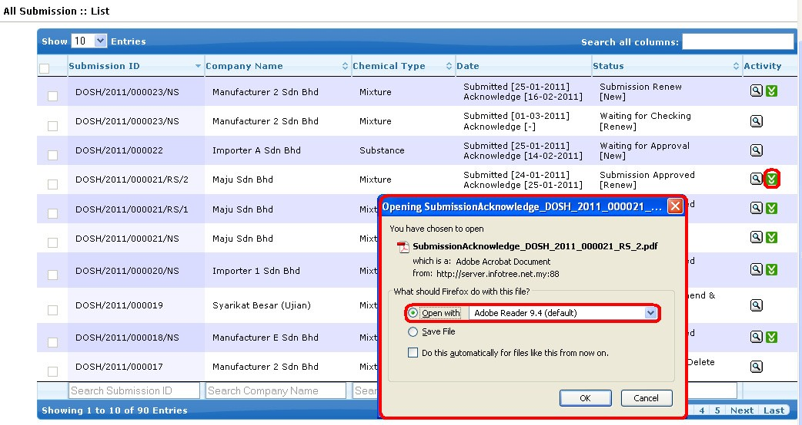

• Select open with or save file

• View report of list all submission

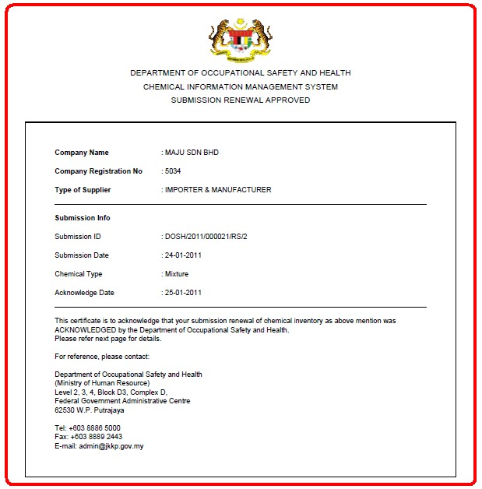

***New Submission: All List***

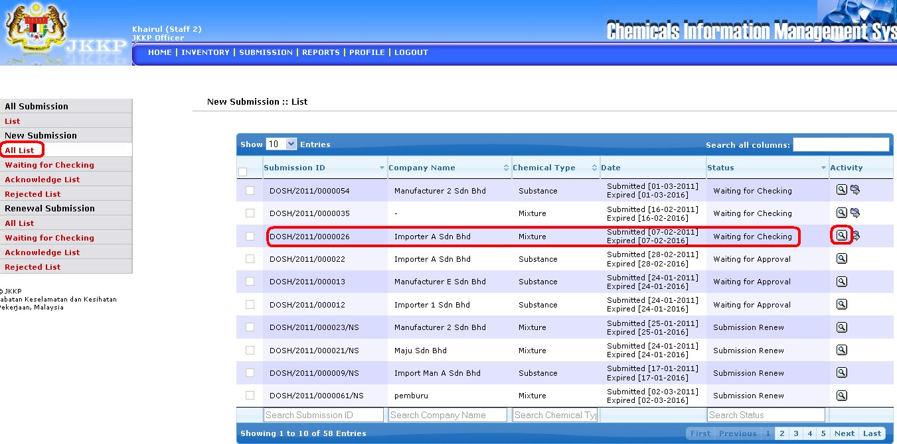

• List of all list new submission

• Click View button



• Details of all list new submission

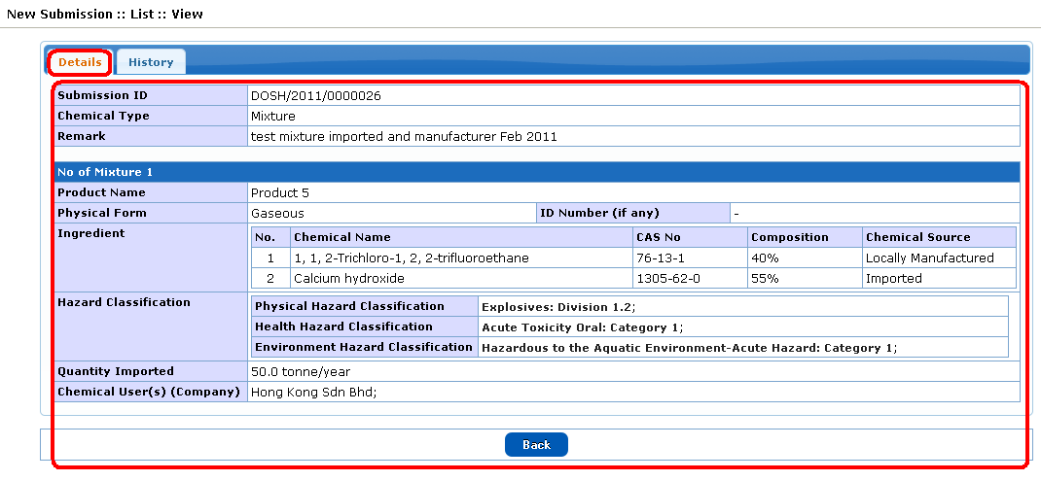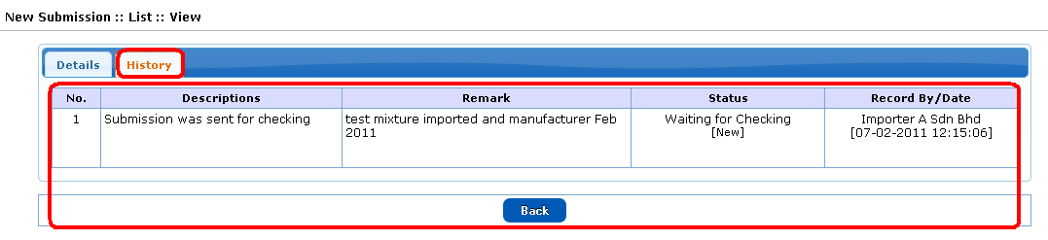

• History of all list new submission

• Click Checking button

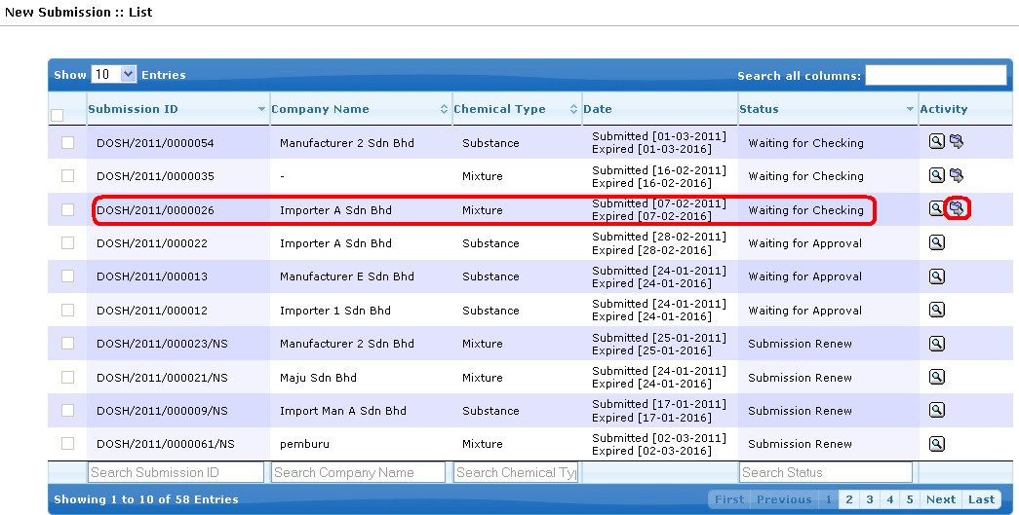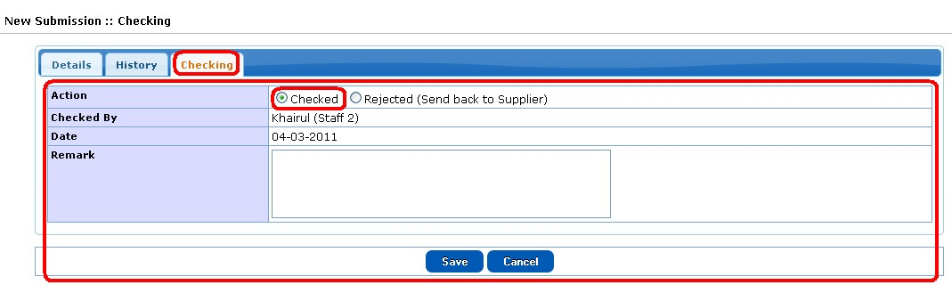

• Click Checked radio button after checked the checking list

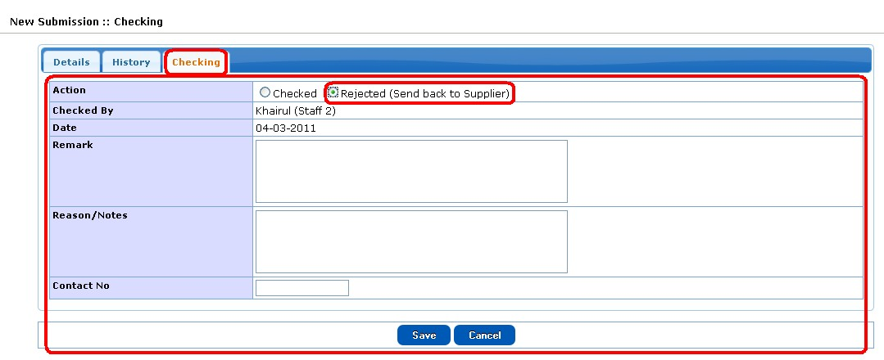

• Click Rejected radio button to reject the list

***Renewal Submission: All List***

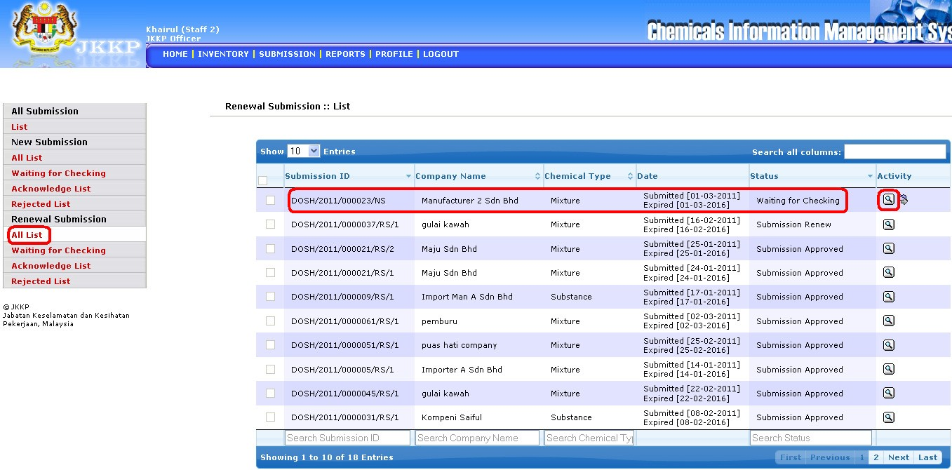

• List of all list renewal submission

• Click View button



• Details of all list renewal submission

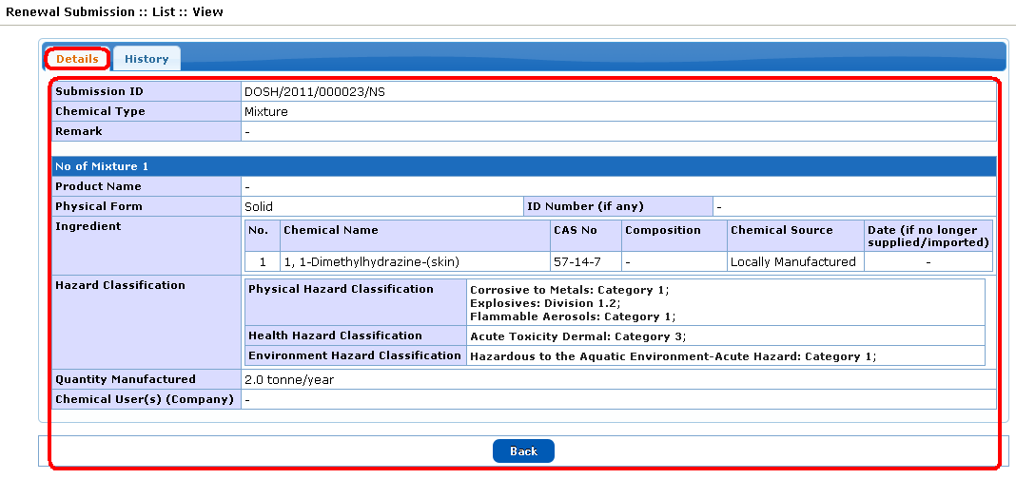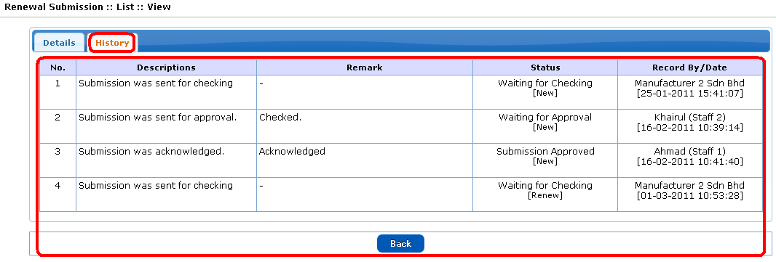

• History of all list renewal submission

**Report**

Report sub menu

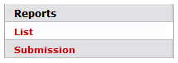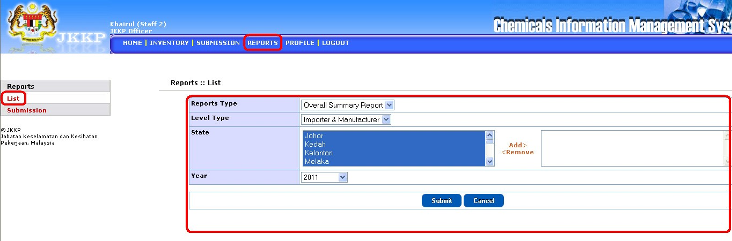

• Select report type, level type, state and year. Click submit button when complete.

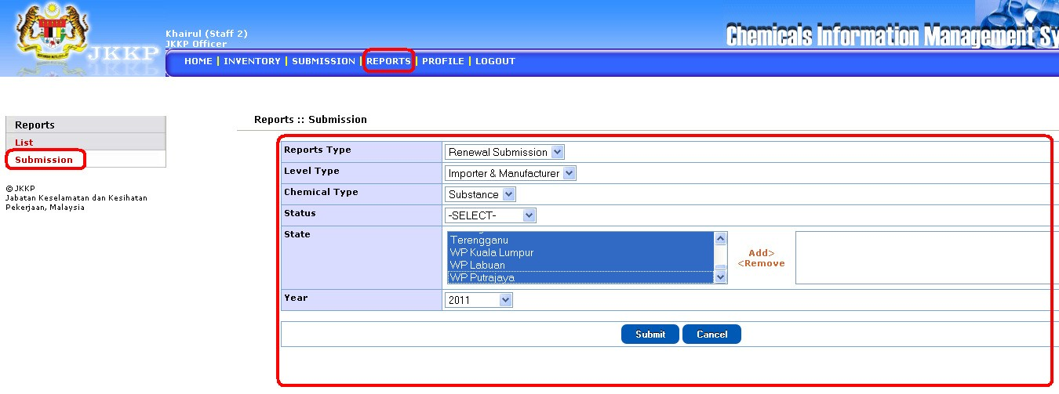

• Select report type, level type, chemical type, status, state and year. Click submit button when complete.

**Profile**

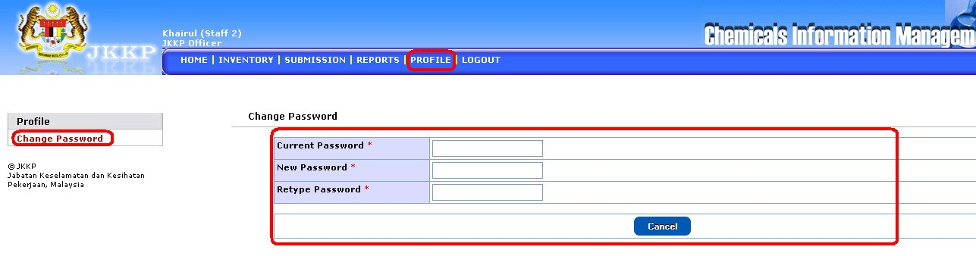

• Change password (if required).